Consumer Purchase Behavior Analysis Report

Scatter plot:

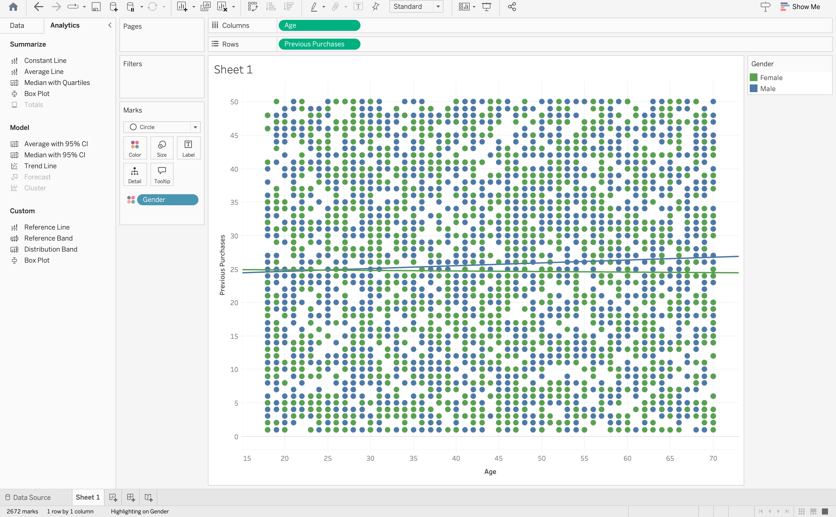

**Executive Summary**

This analysis examines the relationship between customer age, previous purchase behavior, and gender, providing insights for strategic decision-making in consumer engagement and inventory planning.

**Key Findings**

**Purchase Frequency Distribution**

- Customer purchase frequency ranges from 0 to 50 previous purchases

- The average number of previous purchases hovers around 25 across all age groups

- Dense clustering observed between 15-45 previous purchases indicates a strong core customer base

**Age-Based Insights**

- Customer age spans from 15 to 70 years

- Most active purchasing behavior observed in the 25-45 age bracket

- Consistent purchase patterns across all age groups with slight variations

**Gender Analysis**

- Female customers (green) show slightly more consistent purchase patterns

- Male customers (blue) demonstrate a marginally increasing trend with age

- Both genders maintain similar average purchase frequencies (approximately 25)

**Business Implications**

**Customer Retention**

- Strong repeat purchase behavior across all demographics suggests effective retention strategies

- The consistent average of 25 previous purchases indicates stable customer loyalty

**Strategic Opportunities**

- Potential to develop targeted strategies for age groups showing lower engagement

- Opportunity to leverage gender-specific purchasing patterns for marketing initiatives

- Room for growth in customer segments showing below-average purchase frequency

**Recommendations**

1. Targeted Marketing

- Develop age-specific marketing campaigns focusing on underperforming segments

- Create gender-specific promotions based on observed purchasing patterns

2. Loyalty Programs

- Implement tiered rewards systems based on purchase frequency clusters

- Design special incentives for customers in the 15-25 previous purchase range

3. Inventory Planning

- Adjust stock levels based on age-gender purchase patterns

- Plan for consistent demand across age groups